**Flight Management System**



**Project Report**

**SCD**

**Section: BSE - 5B**

21K-3838 Arqam Habib

21K-3821 Haroon Mirza

21K-3874 Saqib Sheikh

1. **Introduction**

The Flight Management & Booking System project aims to develop a comprehensive software system for managing various aspects of flight operations. This system will allow the admin to manage flights, airlines and aircrafts, providing detailed report about a particular flight, airline or aircraft. It will also provide an interface for booking tickets along with secure payment method for passengers.

1. **Objectives**

**Efficient Booking Process:** Enable users to easily search for flights, compare prices, and book tickets seamlessly.

**Effective Management:** Streamline the management of flight schedules, aircraft and airlines.

**Customer Satisfaction:** Enhance the overall customer experience through user-friendly interfaces and reliable services.

**Data Security:** Ensure the security and privacy of sensitive passenger and financial information.

1. **Design**

**User Interface (UI):** Design an intuitive and user-friendly interface for both customers and airline staff.

**Database Design:** Develop a robust database to store and manage flight schedules, customer information, and transaction data.

1. **Results**

**Booking Efficiency:** The Flight Booking System has shown to significantly reduce booking time for passengers.

**Database Management Efficiency:** The Flight Management System has shown to significantly reduce the time & effort needed to maintain the flight related databases by admin.

**Customer Satisfaction**: A user friendly interface enabled easy navigation through the process of managing induvial flights, airlines and aircrafts for the admin.

Similarly, an easy to use, user friendly booking system helped passengers to make bookings in record time.

1. **Limitations:**

**Technical Constraints:** The system may face limitations due to the technology stack chosen or external dependencies.

**Regulatory Compliance:** Adherence to aviation regulations and data protection laws may impose limitations on certain functionalities.

**Resource Allocation:** Limited resources, both in terms of hardware and personnel, may impact system performance and development speed.

**Security Concerns:** Despite efforts to secure the system, there may still be vulnerabilities that could be exploited.

1. **Future Updates:**

**Artificial Intelligence (AI) Integration:** We will implement AI-driven chatbots for customer support to assist users with queries, booking processes, and personalized recommendations.

**Biometric Authentication:** We will integrate a biometric authentication method (such as facial recognition or fingerprint scanning) for streamlined and secure passenger identification during the booking and check-in processes.

1. **Testing Use Cases:**

**Flight Search and Booking:**

**Test Case 1: Successful Flight Search**

**Input**: Departure and destination cities, date

**Expected Output**: A list of available flights matching the criteria is displayed.

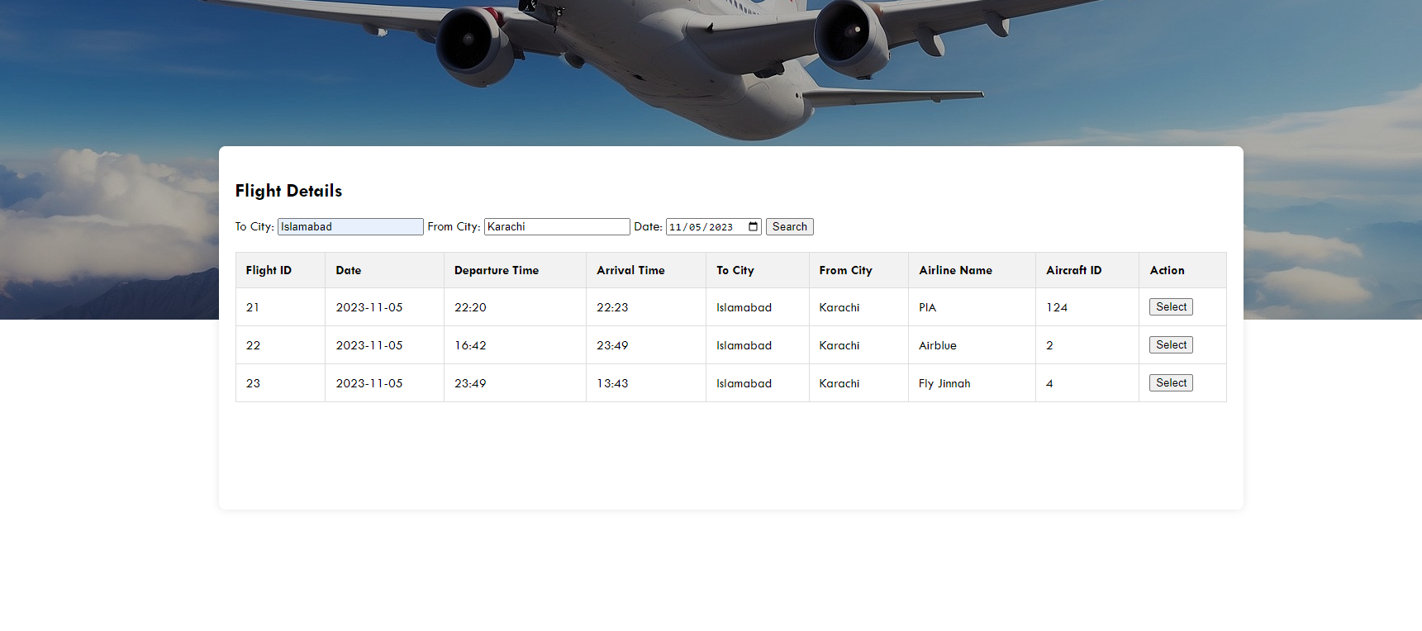

**Test Case 2: Booking Confirmation**

**Input**: Select a flight and complete the booking process

**Expected Output**: Booking confirmation page with details of the reserved flight and passenger information.

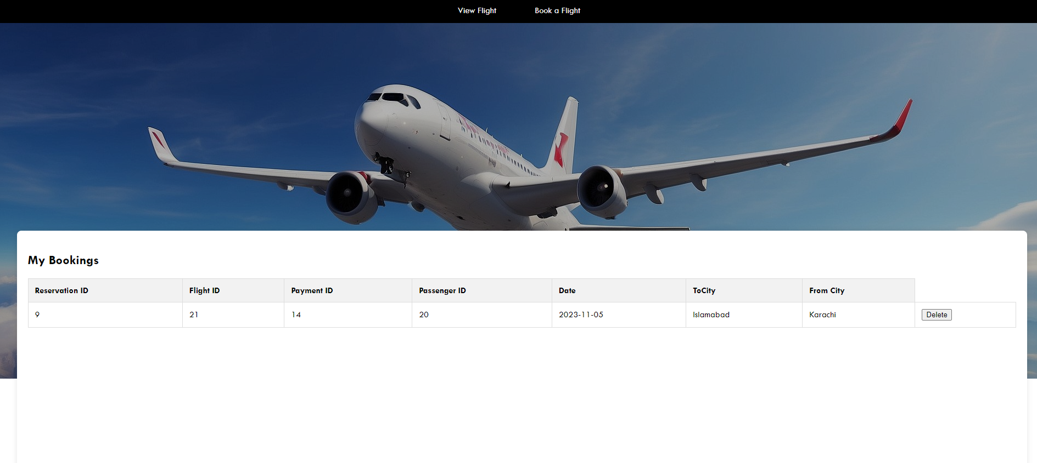

**User Registration and Login:**

**Test Case 3: Successful Registration**

**Input**: Valid user details (first name, last name, username, email, password)

**Expected** Output: User is registerd

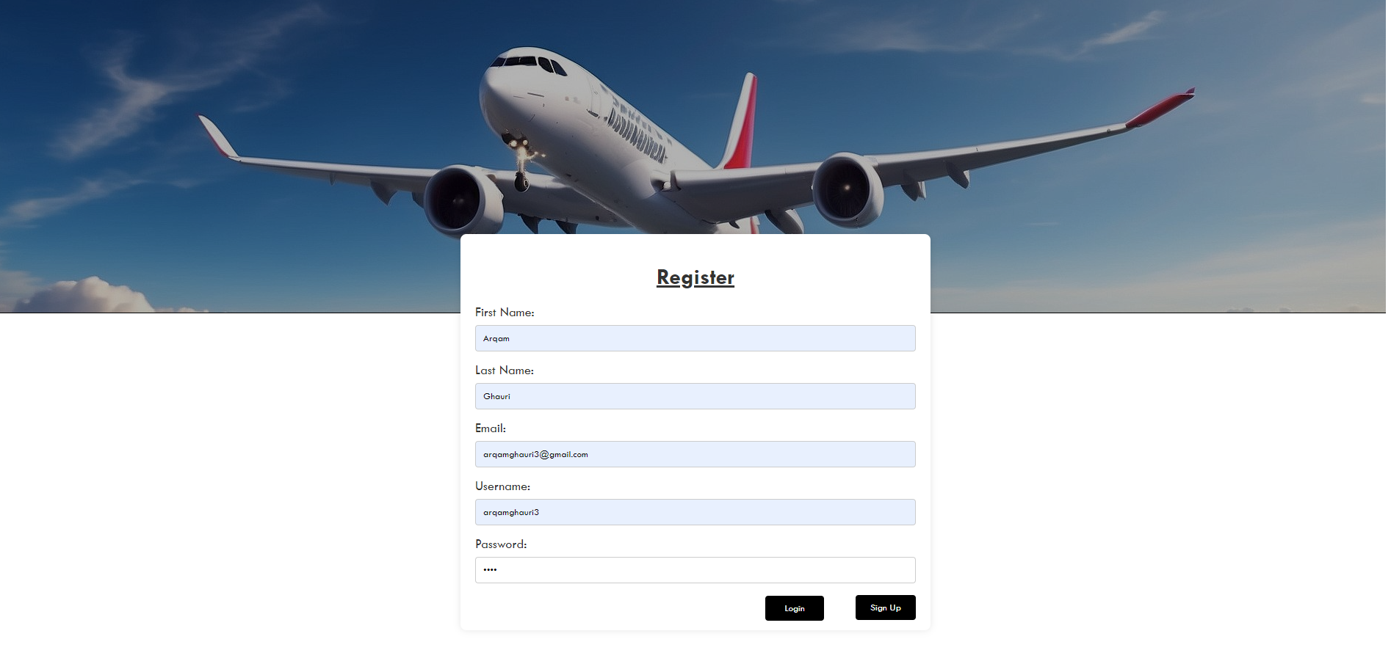

**Test Case 4: Successful Login**

**Input**: Valid user details (username, password)

**Expected** Output: User is logged in

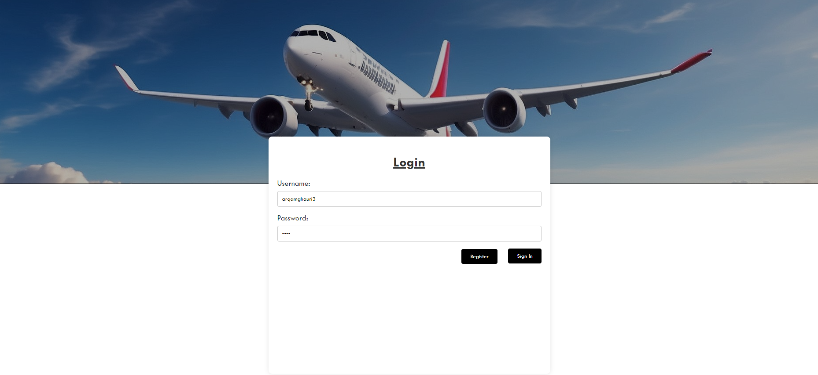

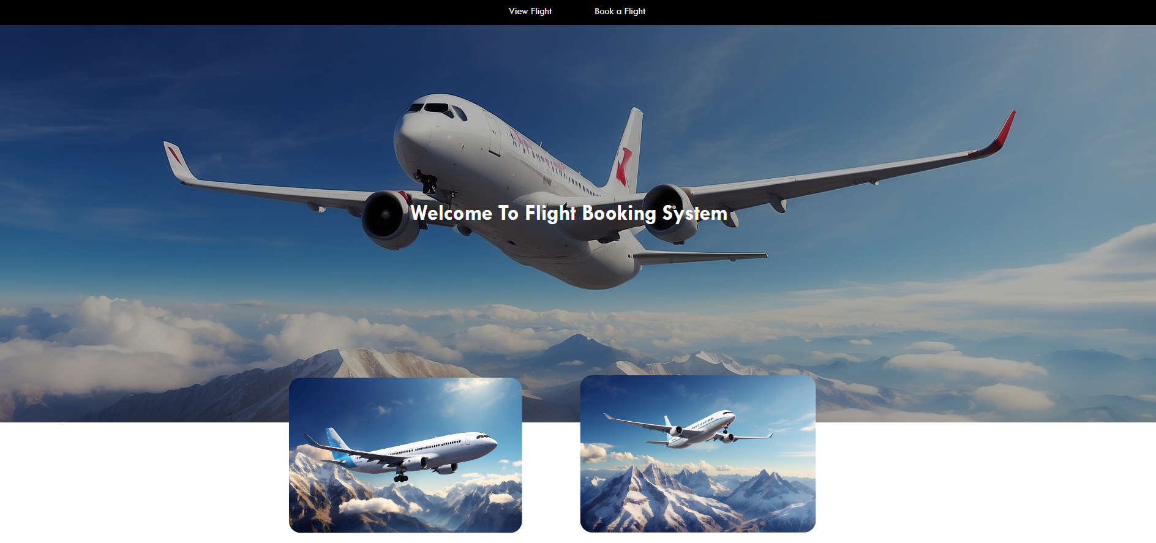

1. **Conclusion:**

In conclusion, developing a Flight Management and Booking System requires a meticulous and adaptable approach. Prioritizing security, compliance, and user experience is essential. The iterative nature of development, coupled with post-implementation support and ongoing improvements, ensures the system remains responsive to evolving aviation needs. Ultimately, the success of the system is measured not only by its technical capabilities but also by its ability to enhance the booking experience, streamline operations, and contribute to the efficiency and safety of the aviation industry.